15.74: (a) The breaking stress is 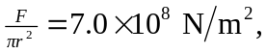and the maximum tension is 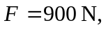so solving for r gives the minimum radius 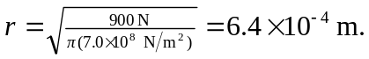 The mass and density are fixed, 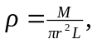 so the minimum radius gives the maximum length 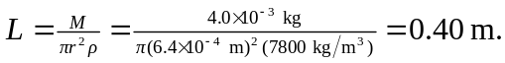

(b) The fundamental frequency is 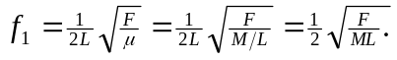 Assuming the maximum length of the string is free to vibrate, the highest fundamental frequency occurs when 